CSEISMIC 1.0 Technical Specifications

1/8/2016

Table of Contents

[1 Microgrid Controller 1](#_Toc448836475)

[1.1 Software Interface 1](#_Toc448836476)

[1.1.1 RTDS 3](#_Toc448836477)

[1.1.2 DECC 3](#_Toc448836478)

[1.1.3 Communication 3](#_Toc448836479)

[1.1.4 State Diagram 3](#_Toc448836480)

[1.2 Hardware Setup 4](#_Toc448836481)

[1.2.1 RTDS 4](#_Toc448836482)

[1.2.2 Controller 5](#_Toc448836483)

[1.3 User Interface 5](#_Toc448836484)

[1.4 Visualization 5](#_Toc448836485)

[1.5 Optimization 7](#_Toc448836486)

[2 Energy Storage IED Controller 8](#_Toc448836487)

[2.1 Software Interface 8](#_Toc448836488)

[2.1.1 IP Address and Port 8](#_Toc448836489)

[2.1.2 Modbus Communication 8](#_Toc448836490)

[2.1.3 State Diagram 10](#_Toc448836491)

[2.2 Hardware Setup 10](#_Toc448836492)

[2.2.1 RTDS 10](#_Toc448836493)

[2.2.2 Controller 10](#_Toc448836494)

[3 PV IED Controller 12](#_Toc448836495)

[3.1 Software Interface 12](#_Toc448836496)

[3.1.1 IP Address and Port 12](#_Toc448836497)

[3.1.2 RTDS Modbus Communication 12](#_Toc448836498)

[3.1.3 DECC Modbus Communication 13](#_Toc448836499)

[3.2 Hardware Setup 16](#_Toc448836500)

[3.2.1 RTDS 16](#_Toc448836501)

[3.2.2 AE75TX 16](#_Toc448836502)

[4 DC Generator IED Controller 18](#_Toc448836503)

[4.1 Software Interface 18](#_Toc448836504)

[4.1.1 IP Address and Port 18](#_Toc448836505)

[4.1.2 Modbus Communication 18](#_Toc448836506)

[4.1.3 State Diagram 20](#_Toc448836507)

[4.2 Hardware Setup 20](#_Toc448836508)

[4.2.1 RTDS 20](#_Toc448836509)

[4.2.2 Controller 21](#_Toc448836510)

[5 Microgrid Switch IED Controller 22](#_Toc448836511)

[5.1 Software Interface 22](#_Toc448836512)

[5.1.1 IP Address and Port 22](#_Toc448836513)

[5.1.2 Modbus Communication 22](#_Toc448836514)

[5.1.3 State Diagram 24](#_Toc448836516)

[5.2 Hardware Setup 24](#_Toc448836517)

[5.2.1 RTDS 24](#_Toc448836518)

[5.2.2 Controller 24](#_Toc448836519)

[6 Relay IED Controller 26](#_Toc448836520)

[6.1 Software Interface 26](#_Toc448836521)

[6.1.1 IP Address and Port 26](#_Toc448836522)

[6.1.2 Modbus Communication 26](#_Toc448836523)

[6.1.3 State Diagram 28](#_Toc448836524)

[6.2 Hardware Setup 28](#_Toc448836525)

[6.2.1 RTDS 28](#_Toc448836526)

[6.2.2 Controller 28](#_Toc448836527)

[Appendix A: Communications between EMS/SCADA 29](#_Toc448836528)

[Appendix B: EMS States 37](#_Toc448836529)

[Appendix C: Modbus Files 44](#_Toc448836530)

# List of Figures

[Figure 1. Main Communications Architecture. 2](#_Toc448836631)

[Figure 2. Overall Flow from State to State. 4](#_Toc448836632)

[Figure 3. User Interface. 5](#_Toc448836633)

[Figure 4. RTDS Lab Initial Test Case. 6](#_Toc448836634)

[Figure 5. Energy Storage IED State Diagram. 10](#_Toc448836635)

[Figure 6. 14](#_Toc448836636)

[Figure 7. 17](#_Toc448836637)

[Figure 8. Generator IED state diagram. 20](#_Toc448836638)

[Figure 9. Microgrid Switch IED States. 24](#_Toc448836639)

[Figure 10. Relay IED States. 28](#_Toc448836640)

# 

# Microgrid Controller

This document is intended as a resource for users of the Complete System-level Efficient and Interoperable Solution for Microgrid Integrated Controls (CSEISMIC). CSEISMIC is currently being used in both the real time digital simulator (RTDS) testbed and in the full-voltage Distributed Energy Communications and Controls (DECC) lab implementation. Differences between the two types will be documented here.

## Software Interface

The main software in the first version of CSEISMIC is composed of MathWorks MATLAB and National Instruments LabVIEW components. MATLAB apps are used for forecasting, the energy management system (EMS), visualization, optimization, and polling of price signals, as shown in Figure 1. LabVIEW communicates to the devices through Modbus over TCP/IP and basic SCADA functions. The main host computer runs both MATLAB and LabVIEW, and a communications protocol was developed to exchange information between the two systems. A list of the current communications commands between MATLAB and LabVIEW are provided in Appendix A.

The system is initialized through a set of files that define both the system configuration and the communications. These are .ini files that are hosted in the MATLAB EMS and sent to the LabVIEW SCADA system during initial startup. The startup sequence diagram is provided in Appendix B. The CID\_load function command initializes the devices that the EMS has sent SCADA and performs the initial interconnection to the devices. Example ini files for the devices are provided in Appendix C.

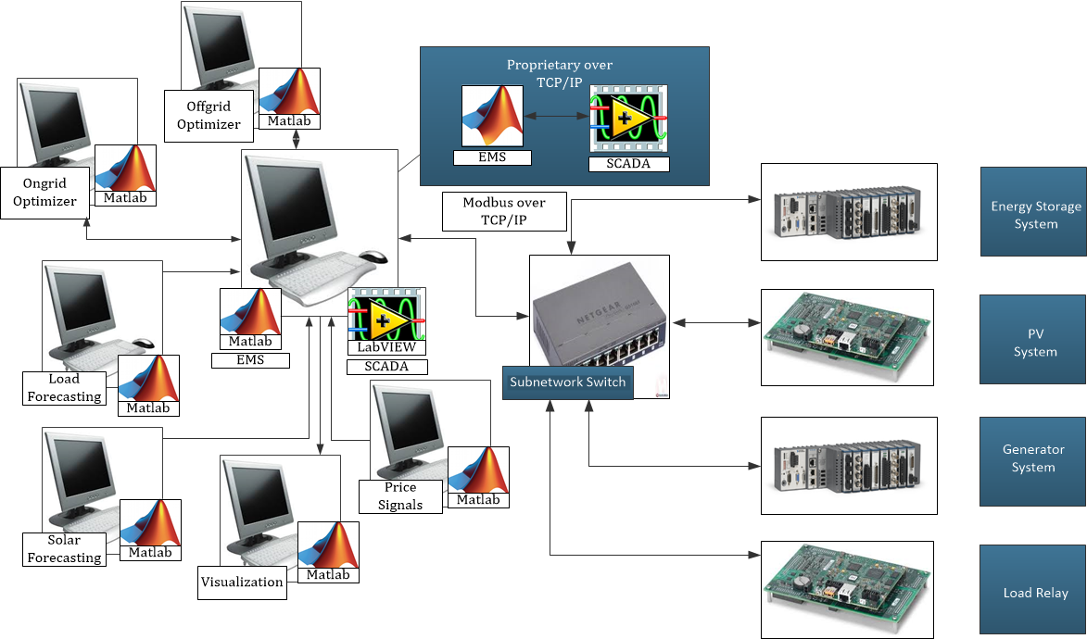

Figure 1. Main Communications Architecture.

### RTDS

#### IP Address

The IP address of the RTDS type will be statically assigned as 192.168.48.153.

#### Port

The port used for Modbus communication is 502.

### DECC

#### IP Address

The IP address of the DECC type will be statically assigned as 192.168.48.153.

#### Port

The port used for Modbus communication is 502.

### Communication

Multiple communication channels are open for the master controller. The EMS and SCADA communicate as server/client on two ports for basic message exchange. A separate channel is open for the EMS/SCADA to exchange emergency information such as that for unintentional islanding or faults. Another communication channel provides information from SCADA to the visualization graphical user interface (GUI) that gives status information on the microgrid operations as a MATLAB app. The EMS pulls files on forecast results and pricing information from other MATLAB apps on other computers in the laboratory.

#### Commands

Commands between the EMS and SCADA for normal operations can be found in Appendix A.

The configuration files that provide information regarding the Modbus addressing of information can be found in Appendix C.

### State Diagram

The main state diagram for the operations of the EMS is shown in Figure 2. Other diagrams representing sub-states are in Appendix B. At this stage, eight states have been developed to test the initial development of CSEISMIC.

CSEISMIC_designs_vs2

Figure 2. Overall Flow from State to State.

## Hardware Setup

The following is a description of all the hardware used for the microgrid controller.

### RTDS

The microgrid controller in conjunction with the RTDS simulation is based on the following hardware.

### Controller

The main controller is on a HP Z840 running LabVIEW 2014 SP1 and MATLAB 2014a. Although this is deployable on any computer, older model computers may have issues running MATLAB and LabVIEW, depending on the processor and availability of memory.

## User Interface

The user interface is directly linked to the EMS and is done in MATLAB. A depiction is shown in Figure 3. User options on startup are provided along with current status updates, system failure statues, modes of operations.

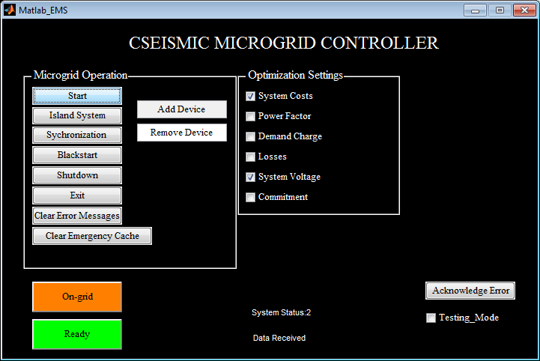

Figure 3. User Interface.

## Visualization

The background of the GUI is a Google Earth screen capture with overlays of device status and measurements (Figure 4). The red color denotes that the device is active and operating. The green color denotes that the devices are deactivated and not operating.[[1]](#footnote-1)

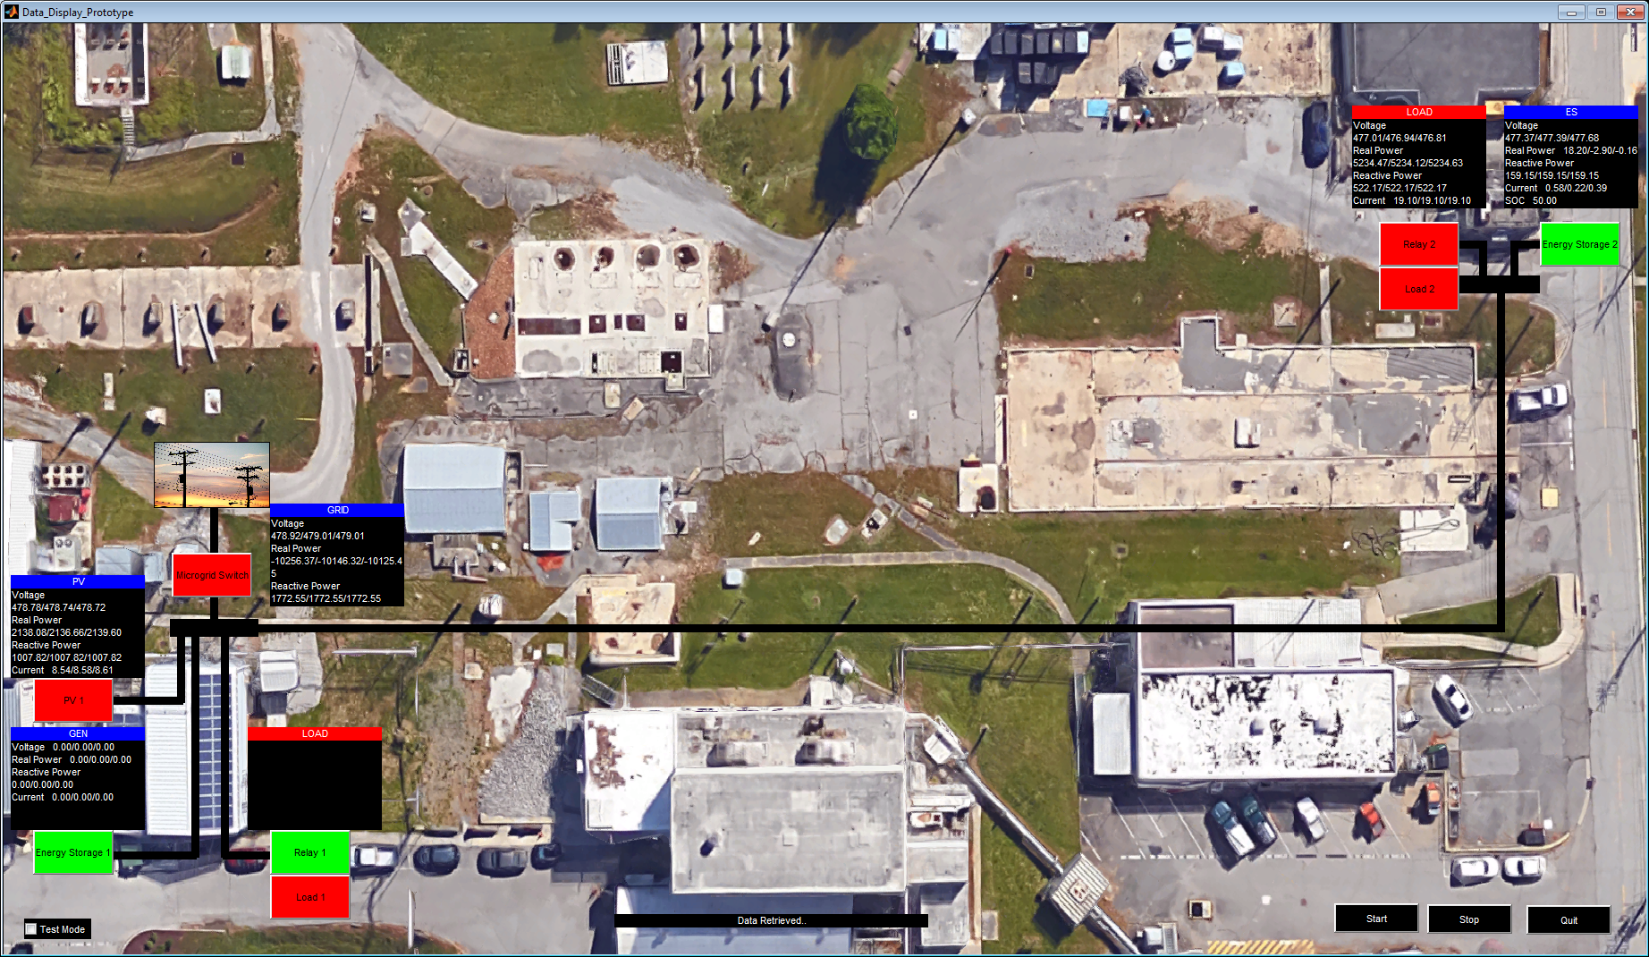

Figure 4. RTDS Lab Initial Test Case.

# Energy Storage IED Controller

This section documents the software and hardware interfaces to the energy storage intelligent electrical device (IED) controller. This controller is currently being used in the RTDS testbed.

## Software Interface

The device interfaces with the microgrid controller through Modbus over TCP. Below are definitions of the Modbus commands and addresses.

### IP Address and Port

***IP Address***

The IP address of the RTDS type will be statically assigned as 192.168.48.151.

***Port***

The port used for Modbus communication is 502.

### Modbus Communication

#### Commands

The following are commands sent from SCADA to the IED. These commands cause changes of state directly.

|  |  |  |
| --- | --- | --- |
| Address | Keyword | Description |
| 00010 | Activate | Causes the IED to move from an inactive to an active state |
| 00020 | Deactivate | Causes the IED to move from an active to an inactive state |
| 10032 | Sync | When in V/f mode, causes the IED to prepare for grid synchronization |
| 10030 | Generation Mode | Default (F) behavior is PQ Mode. Active (T) makes it go into V/f Mode |
| 10031 | Droop | Causes Droop to be on (T) or off (F) |

#### Statuses

The following are status registers that give information from the IED to SCADA about changes of state.

|  |  |  |
| --- | --- | --- |
| Address | Keyword | Description |
| 10010 | Activate | Whether or not the IED is in an active state |
| 10011 | Deactivate | Whether or not the IED is in an inactive state |

#### Variables

These registers contain static information about the IED needed for operation and optimization.

|  |  |  |
| --- | --- | --- |
| Address | Keyword | Description |
| 30010 | Activate Timeout | Specifies the maximum amount of time (seconds) that the IED should take to activate |
| 30020 | Deactivate Timeout | Specifies the maximum amount of time (seconds) that the IED should take to deactivate |
| 34083 | Battery Capacity | The maximum capacity of the battery (kW-hour) |
| 39403 | Ramp Rate | The rate at which the source can increase power output (W/second) |

#### Setpoints

These registers contain the values used as setpoints for power generation.

|  |  |  |
| --- | --- | --- |
| Address | Keyword | Description |
| 40030 | Real | Target value for real power generation |
| 40040 | Reactive | Target value for reactive power generation |
| 40050 | Voltage | Target value for RMS voltage |
| 40060 | Frequency | Target frequency |

#### Measurements

These registers pass measurements from the IED to SCADA. Scaling on the SCADA side may be necessary to convert from L-L to L-N or vice-versa.

|  |  |  |
| --- | --- | --- |
| Address | Keyword | Description |
| 30030 | Phase A Current | Current on Phase A (Amps). Positive is current out (Discharge). |
| 30040 | Phase B Current | Current on Phase B (Amps). Positive is current out (Discharge). |
| 30050 | Phase C Current | Current on Phase C (Amps). Positive is current out (Discharge). |
| 30130 | Phase A Voltage | Voltage on Phase A (Volts) |
| 30140 | Phase B Voltage | Voltage on Phase B (Volts) |
| 30150 | Phase C Voltage | Voltage on Phase C (Volts) |
| 30230 | Phase A Real Power | Real power on Phase A (Watts). Positive is output power. |
| 30240 | Phase B Real Power | Real power on Phase B (Watts). Positive is output power. |
| 30250 | Phase C Real Power | Real Power on Phase C (Watts). Positive is output power. |
| 30330 | Phase A Reactive Power | Reactive Power on Phase A (VARs). Positive is output power. |
| 30340 | Phase B Reactive Power | Reactive Power on Phase B (VARs). Positive is output power. |
| 30350 | Phase C Reactive Power | Reactive Power on Phase C (VARs). Positive is output power. |
| 30500 | State of Charge | The state of charge of the battery (0-100). |

#### Watchdog

This register is used to provide watchdog functionality to the IED. If the value in the register does not change within 10 seconds, the IED is to assume it has lost communication with SCADA.

|  |  |  |
| --- | --- | --- |
| Address | Keyword | Description |
| 40010 | Watchdog | Register that changes over time when connected to SCADA |

### State Diagram

The state diagram for the operation of the energy storage IED is shown in Figure 5.

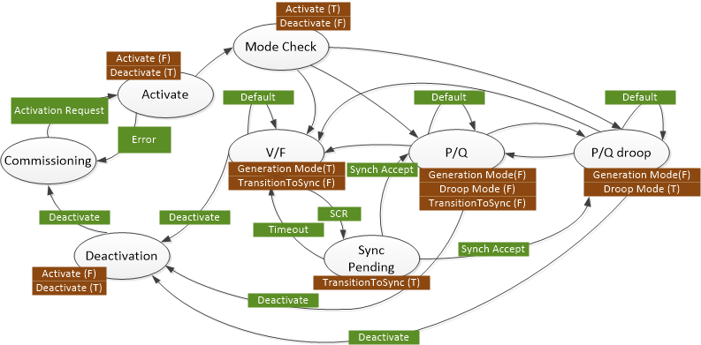

Figure 5. Energy Storage IED State Diagram.

## Hardware Setup

The following is a description of all the hardware used for the energy storage controllers.

### RTDS

The energy storage controller in conjunction with the RTDS simulation is based on the following hardware.

### Controller

The main inverter controller for the energy storage device is a National Instruments cRIO-9030 running LabVIEW 2014 SP1.

#### Module Configuration

|  |  |  |
| --- | --- | --- |
| Slot | Device | Description |
| 1 | NI 9220 | Analog Input |
| 2 | NI 9264 | Analog Output |

#### Channel Configuration

|  |  |  |
| --- | --- | --- |
| Slot | Channel | Description |
| 1 | AI0 | Inverter Current Phase A |
| 1 | AI1 | Inverter Current Phase B |
| 1 | AI2 | Inverter Current Phase C |
| 1 | AI3 | Inverter Voltage Phase A |
| 1 | AI4 | Inverter Voltage Phase B |
| 1 | AI5 | Inverter Voltage Phase C |
| 1 | AI6 | DC-link Voltage |
| 1 | AI7 | SOC of Battery |
| 2 | AO0 | Modulation Signal Phase A |
| 2 | AO1 | Modulation Signal Phase B |
| 2 | AO2 | Modulation Signal Phase C |

# PV IED Controller

This section documents the software and hardware interfaces to the Photovoltaic System (PV) IED controller. This controller is being simulated within the RTDS testbed and is a third-party inverter in the full-voltage DECC lab implementation. LabVIEW-based conversion code is used to facilitate communication between the AE75TX inverter and CSEISMIC. Differences between the two types will be documented here.

## Software Interface

The device interfaces with the microgrid controller through Modbus over TCP. Below are definitions of the Modbus commands and addresses.

### IP Address and Port

#### RTDS

***IP Address***

The IP address of the RTDS PV controller will be statically assigned as 192.168.48.71.

***Port***

The port used for Modbus communication is 502.

#### DECC

***IP Address***

The IP address of the AE75TX inverter is statically assigned as 192.168.48.200. The conversion program is running on *localhost* on the CSEISMIC master controller.

***Port***

The port used for Modbus communication with the AE75TX inverter is 502. Modbus communication with the conversion program is performed over port 667.

### RTDS Modbus Communication

#### Commands

The following are commands sent from SCADA to the IED. These commands cause changes of state directly.

|  |  |  |
| --- | --- | --- |
| Address | Keyword | Description |
| 00010 | Activate | Causes the IED to move from an inactive to an active state |
| 00020 | Deactivate | Causes the IED to move from an active to an inactive state |

#### Statuses

The following are status registers that give information from the IED to SCADA about changes of state.

|  |  |  |
| --- | --- | --- |
| Address | Keyword | Description |
| 10010 | Activate | Whether or not the IED is in an active state |
| 10011 | Deactivate | Whether or not the IED is in an inactive state |

#### Variables

These registers contain static information about the IED needed for operation and optimization.

|  |  |  |
| --- | --- | --- |
| Address | Keyword | Description |
| 30010 | Activate Timeout | Specifies the maximum amount of time (seconds) that the IED should take to activate |
| 30020 | Deactivate Timeout | Specifies the maximum amount of time (seconds) that the IED should take to deactivate |

#### Measurements

These registers pass measurements from the IED to SCADA. Scaling on the SCADA side may be necessary to convert from L-L to L-N or vice-versa.

|  |  |  |
| --- | --- | --- |
| Address | Keyword | Description |
| 30030 | Phase A Current | Current on Phase A (Amps) |
| 30040 | Phase B Current | Current on Phase B (Amps) |
| 30050 | Phase C Current | Current on Phase C (Amps) |
| 30130 | Phase A Voltage | Voltage on Phase A (Volts) |
| 30140 | Phase B Voltage | Voltage on Phase B (Volts) |
| 30150 | Phase C Voltage | Voltage on Phase C (Volts) |
| 30230 | Phase A Real Power | Real Power on Phase A (Watts) |
| 30240 | Phase B Real Power | Real Power on Phase B (Watts) |
| 30250 | Phase C Real Power | Real Power on Phase C (Watts) |
| 30330 | Phase A Reactive Power | Reactive Power on Phase A (VARs). Positive is output power. |
| 30340 | Phase B Reactive Power | Reactive Power on Phase B (VARs). Positive is output power. |
| 30350 | Phase C Reactive Power | Reactive Power on Phase C (VARs). Positive is output power. |

#### Watchdog

This register is used to provide watchdog functionality to the IED. If the value in the register does not change within 10 seconds, the IED is to assume it has lost communication with SCADA.

|  |  |  |
| --- | --- | --- |
| Address | Keyword | Description |
| 40010 | Watchdog | Register that changes over time when connected to SCADA |

### DECC Modbus Communication

This communication occurs in two parts. The first part is the communication between the conversion program and the third-party inverter. The second part is the communication between SCADA and the conversion program.

#### Converter

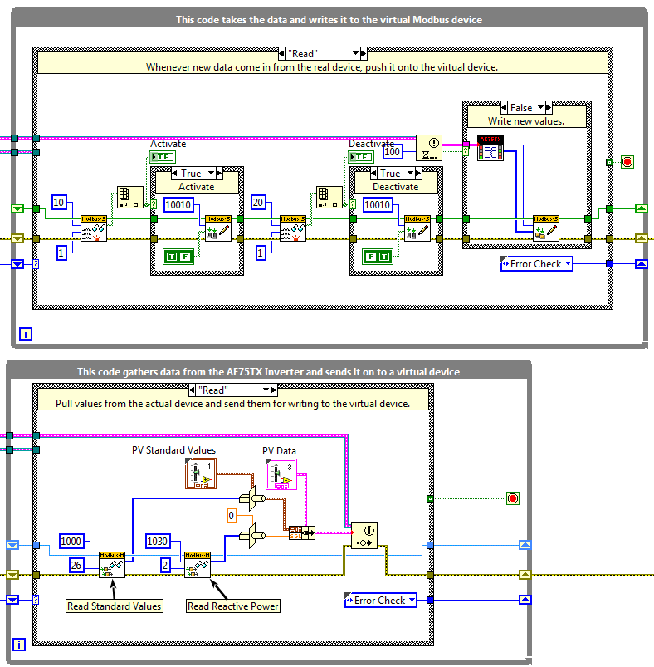

Figure 6 PV communication adapter

The converter (communication adapter) is a very thin program seen in Figure 6 that is meant to convert the measurements taken from the AE75TX inverter to a format expected by SCADA. After reading all values in the bottom loop, they are placed in a cluster and sent via a notifier to the top loop, where they are scaled and reformatted for use in CSEISMIC. Other third-party devices would require a similar code to convert their operation methods to those of CSEISMIC.

Currently only measurements are being taken from the AE75TX inverter, without any control of the device from CSEISMIC. If that functionality were desired, this code could be quickly expanded to allow for bidirectional communication.

#### AE75TX Modbus Addresses

| Address | Keyword | Description |
| --- | --- | --- |
| 1000 | Phase A Voltage | L-N Voltage on Phase A in Volts (SGL) |
| 1002 | Phase B Voltage | L-N Voltage on Phase B in Volts (SGL) |
| 1004 | Phase C Voltage | L-N Voltage on Phase C in Volts (SGL) |
| 1006 | Phase A Current | Current on Phase A in Amps (SGL) |
| 1008 | Phase B Current | Current on Phase B in Amps (SGL) |
| 1010 | Phase C Current | Current on Phase C in Amps (SGL) |
| 1012 | DC Voltage | Voltage on the DC Bus in Volts (SGL) |
| 1014 | DC Current | Current on the DC Bus in Amps (SGL) |
| 1016 | Frequency | Grid Frequency in Hertz (SGL) |
| 1018 | Line Power | PV line power across all phases in kilowatts (SGL) |
| 1020 | Total Power | Total Power Generated by Inverter in kilowatt-hours (U32). |
| 1022 | PV Input | PV Input Voltage in Volts (SGL) |
| 1024 | DC Power | The Power Level of the DC Bus in kilowatts (SGL) |
| 1030 | Reactive Power | Reactive Power Generated across all phases in kVAR (SGL) |

#### Virtual Device Modbus Addresses

##### Control and Status Registers

|  |  |  |
| --- | --- | --- |
| 00010 | Activate Control | Causes the IED to move from an inactive to an active state |
| 00020 | Deactivate  Control | Causes the IED to move from an active to an inactive state |
| 10010 | Activate Status | Whether or not the IED is in an active state |
| 10011 | Deactivate Status | Whether or not the IED is in an inactive state |
| 30010 | Activate Timeout | Specifies the maximum amount of time (seconds) that the IED should take to activate |
| 30020 | Deactivate Timeout | Specifies the maximum amount of time (seconds) that the IED should take to deactivate |

##### Measurement Data

All data elements are sent as double-precision floating point numbers (DBL).

| Address | Keyword | Description |
| --- | --- | --- |
| 30030 | Phase A Current | Current on Phase A in Amps |
| 30034 | Phase B Current | Current on Phase B in Amps |
| 30038 | Phase C Current | Current on Phase C in Amps |
| 30042 | Phase A Voltage | $\sqrt{3}$ Scaled L-N to L-L Voltage on Phase A in Volts |
| 30046 | Phase B Voltage | $\sqrt{3}$ Scaled L-N to L-L Voltage on Phase B in Volts |
| 30050 | Phase C Voltage | $\sqrt{3}$ Scaled L-N to L-L Voltage on Phase C in Volts |
| 30054 | Phase A Real Power | Real Power on Phase A in Watts |
| 30058 | Phase B Real Power | Real Power on Phase B in Watts |
| 30062 | Phase C Real Power | Real Power on Phase C in Watts |
| 30066 | Phase A Reactive Power | Reactive Power on Phase A in VARs |
| 30070 | Phase B Reactive Power | Reactive Power on Phase B in VARs |
| 30074 | Phase C Reactive Power | Reactive Power on Phase C in VARs |
| 30078 | Frequency | Grid Frequency in Hertz |
| 30082 | PV Input | PV Input Voltage in Volts |
| 30086 | DC Voltage | Voltage on the DC Bus in Volts |
| 30090 | DC Current | Current on the DC Bus in Amps |
| 30094 | DC Power | The Power Level of the DC Bus in kilowatts |

## Hardware Setup

The following is a description of all the hardware used for the PV controllers.

### RTDS

The PV controller is simulated within the RTDS. An external device is used only for gathering data from the RTDS and communicating it to CSEISMIC via Modbus and to control the activation and deactivation of PV through a digital output.

### AE75TX

The PV inverter is a model AE75TX inverter from Advanced Energy. This inverter is currently connected to a 50 kW PV array consisting of SunPower 305 series panels. The configuration of the array is seven solar panels per string and 24 strings in parallel. The system includes built-in AC and DC disconnects for servicing the system and is rated to break current flow. The system includes redundant cooling systems with variable speed fans and fault detection. The inverter includes anti-islanding protection, which is designed to prevent the inverter from feeding power during a utility outage. There are field-selectable voltage and frequency trip points which are defaulted to meet UL1741 anti-islanding requirement. The default values for these for the 480 V system are voltage phase high (304.8 V, 1 second), voltage phase low (243.9 V, 2 seconds), voltage phase fast high (332.5 V, 0.16 seconds), voltage phase fast low (138.6 V, 0.16 seconds), line frequency low (59.3 Hz, 0.16 seconds), and line frequency high (60.5 Hz, 0.16 seconds).

The inverter includes a communication interface which accepts Modbus over TCP/IP as shown in Figure 7. Available functionality of this inverter includes advanced control options which include power curtailment, power factor control, monitoring of status and faults, and remote disable. More information on the unit can be found in the online document AE75-100TX-570-1001793-05B-Manual.pdf.

|  |  |
| --- | --- |
| \\ornl\naoa\Projects\DECC-Testing\04_Equipment\50kW PV Array\PV System\Photos & Power Up\array ORNL 9-30-08 044.jpg |  |

Figure 7. PV system with inverter

# DC Generator IED Controller

This section documents the software and hardware interfaces to the DC generator with inverter IED controller. This controller is currently being used in both the RTDS testbed and in the full-voltage DECC lab implementation. Current differences between the two types will be documented here, although it is possible that the two will become different enough to require independent documentation.

## Software Interface

The device interfaces with the microgrid controller through Modbus over TCP. Below are definitions of the Modbus commands and addresses.

### IP Address and Port

#### RTDS

***IP Address***

The IP address of the RTDS type will be statically assigned as 192.168.48.187.

***Port***

The port used for Modbus communication is 502.

#### DECC

***IP Address***

The IP address of the RTDS type will be statically assigned as 192.168.48.082.

***Port***

The port used for Modbus communication is 502.

### Modbus Communication

#### Commands

The following are commands sent from SCADA to the IED. These commands cause changes of state directly.

|  |  |  |
| --- | --- | --- |
| Address | Keyword | Description |
| 00010 | Activate | Causes the IED to move from an inactive to an active state |
| 00020 | Deactivate | Causes the IED to move from an active to an inactive state |
| 10032 | Sync | When in V/f mode, causes the IED to prepare for grid synchronization |
| 10030 | Generation Mode | Default (F) behavior is PQ Mode. Active (T) makes it go into V/f Mode. |
| 10031 | Droop | Causes Droop to be on (T) or off (F) |

#### Statuses

The following are status registers that give information from the IED to SCADA about changes of state.

|  |  |  |
| --- | --- | --- |
| Address | Keyword | Description |
| 10010 | Activate | Whether or not the IED is in an active state |
| 10011 | Deactivate | Whether or not the IED is in an inactive state |

#### Variables

These registers contain static information about the IED needed for operation and optimization.

|  |  |  |
| --- | --- | --- |
| Address | Keyword | Description |
| 30010 | Activate Timeout | Specifies the maximum amount of time (seconds) that the IED should take to activate |
| 30020 | Deactivate Timeout | Specifies the maximum amount of time (seconds) that the IED should take to deactivate |
| 34083 | Battery Capacity | The maximum capacity of the battery (kW-hr) |
| 39403 | Ramp Rate | The rate at which the source can increase power output (in W/second) |

#### Setpoints

These registers contain the values used as setpoints for power generation.

|  |  |  |
| --- | --- | --- |
| Address | Keyword | Description |
| 40030 | Real | Target value for real power generation |
| 40040 | Reactive | Target value for reactive power generation |
| 40050 | Voltage | Target value for RMS voltage |
| 40060 | Frequency | Target frequency |

#### Measurements

These registers pass measurements from the IED to SCADA. Scaling on the SCADA side may be necessary to convert from L-L to L-N or vice-versa.

| Address | Keyword | Description |
| --- | --- | --- |
| 30030 | Phase A Current | Current on Phase A (Amps). Positive is current out (Discharge). |
| 30040 | Phase B Current | Current on Phase B (Amps). Positive is current out (Discharge). |
| 30050 | Phase C Current | Current on Phase C (Amps). Positive is current out (Discharge). |
| 30130 | Phase A Voltage | Voltage on Phase A (Volts) |
| 30140 | Phase B Voltage | Voltage on Phase B (Volts) |
| 30150 | Phase C Voltage | Voltage on Phase C (Volts) |
| 30230 | Phase A Real Power | Real Power on Phase A (Watts). Positive is output power. |
| 30240 | Phase B Real Power | Real Power on Phase B (Watts). Positive is output power. |
| 30250 | Phase C Real Power | Real Power on Phase C (Watts). Positive is output power. |
| 30330 | Phase A Reactive Power | Reactive Power on Phase A (VARs). Positive is output power. |
| 30340 | Phase B Reactive Power | Reactive Power on Phase B (VARs). Positive is output power. |
| 30350 | Phase C Reactive Power | Reactive Power on Phase C (VARs). Positive is output power. |

#### Watchdog

This register is used to provide watchdog functionality to the IED. If the value in the register does not change within 10 seconds, the IED is to assume it has lost communication with SCADA.

|  |  |  |
| --- | --- | --- |
| Address | Keyword | Description |
| 40010 | Watchdog | Register that changes over time when connected to SCADA. |

### State Diagram

Figure 8 is the state diagram for the operation of the generator IED.



Figure 8. Generator IED state diagram.

## Hardware Setup

The following is a description of all the hardware used for the generator controllers.

### RTDS

The generator controller in conjunction with the RTDS simulation is based on the following hardware.

### Controller

The main inverter controller for the energy storage device is a National Instruments cRIO-9030 running LabVIEW 2014 SP1.

#### Module Configuration

The module configuration is as follows.

|  |  |  |
| --- | --- | --- |
| Slot | Device | Description |
| 1 | NI 9220 | Analog Input |
| 2 | NI 9474 | Digital Output |

#### Channel Configuration

|  |  |  |
| --- | --- | --- |
| Slot | Channel | Description |
| 1 | AI0 | Status Signal of Microgrid Switch |
| 1 | AI1 | Grid Voltage Phase A |
| 1 | AI2 | Grid Voltage Phase B |
| 1 | AI3 | Grid Voltage Phase C |
| 1 | AI4 | Microgrid Voltage Phase A |
| 1 | AI5 | Microgrid Voltage Phase B |
| 1 | AI6 | Microgrid Voltage Phase C |
| 1 | AI7 | Grid Current Phase A |
| 1 | AI8 | Grid Current Phase B |
| 1 | AI9 | Grid Current Phase C |
| 2 | DO0 | Open Microgrid Switch Signal |
| 2 | DO1 | Close Microgrid Switch Signal |

# Microgrid Switch IED Controller

This section documents the software and hardware interfaces to the microgrid switch IED controller. This controller is currently being used in both the RTDS testbed and in the full-voltage DECC lab implementation. Current differences between the two types will be documented here, although it is possible that the two will become different enough to require independent documentation.

## Software Interface

The device interfaces with the microgrid controller through Modbus over TCP. Below are definitions of the Modbus commands and addresses.

### IP Address and Port

#### RTDS

***IP Address***

The IP address of the RTDS type will be statically assigned as 192.168.48.250.

***Port***

The port used for Modbus communication is 502.

#### DECC

***IP Address***

The IP address of the RTDS type will be statically assigned as 192.168.48.154.

***Port***

The port used for Modbus communication is 502.

### Modbus Communication

#### Commands

The following are commands sent from SCADA to the IED. These commands cause changes of state directly.

|  |  |  |
| --- | --- | --- |
| Address | Keyword | Description |
| 00010 | Activate | Causes the IED to move from an inactive to an active state |
| 00020 | Deactivate | Causes the IED to move from an active to an inactive state |

#### Statuses

The following are status registers that give information from the IED to SCADA about changes of state.

|  |  |  |
| --- | --- | --- |
| Address | Keyword | Description |
| 10010 | Activate | Whether or not the IED is in an active state |
| 10011 | Deactivate | Whether or not the IED is in an inactive state |

#### Variables

These registers contain static information about the IED needed for operation and optimization.

|  |  |  |
| --- | --- | --- |
| Address | Keyword | Description |
| 30010 | Activate Timeout | Specifies the maximum amount of time (seconds) that the IED should take to activate |
| 30020 | Deactivate Timeout | Specifies the maximum amount of time (seconds) that the IED should take to deactivate |

#### Setpoints

There are no setpoints for the microgrid switch.

#### Measurements

These registers pass measurements from the IED to SCADA. Scaling on the SCADA side may be necessary to convert from L-L to L-N or vice-versa.

|  |  |  |
| --- | --- | --- |
| Address | Keyword | Description |
| 30030 | Phase A Current | Current on Phase A (Amps). Positive is current out (Discharge) |
| 30040 | Phase B Current | Current on Phase B (Amps). Positive is current out (Discharge) |
| 30050 | Phase C Current | Current on Phase C (Amps). Positive is current out (Discharge) |
| 30130 | Phase A Voltage | Grid Voltage on Phase A (Volts) |
| 30140 | Phase B Voltage | Grid Voltage on Phase B (Volts) |
| 30150 | Phase C Voltage | Grid Voltage on Phase C (Volts) |
| 30230 | Phase A Real Power | Real Power on Phase A (Watts). Positive is output power. |
| 30240 | Phase B Real Power | Real Power on Phase B (Watts). Positive is output power. |
| 30250 | Phase C Real Power | Real Power on Phase C (Watts). Positive is output power. |
| 30330 | Phase A Reactive Power | Reactive Power on Phase A (VARs). Positive is output power. |
| 30340 | Phase B Reactive Power | Reactive Power on Phase B (VARs). Positive is output power. |
| 30350 | Phase C Reactive Power | Reactive Power on Phase C (VARs). Positive is output power. |

#### Watchdog

This register is used to provide watchdog functionality to the IED. If the value in the register does not change within 10 seconds, the IED is to assume it has lost communication with SCADA.

|  |  |  |
| --- | --- | --- |
| Address | Keyword | Description |
| 40010 | Watchdog | Register that changes over time when connected to SCADA. |

### State Diagram

Figure 9 is the state diagram for the operation of the microgrid switch IED.

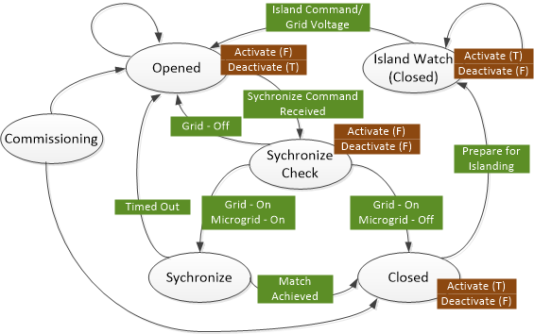

Figure 9. Microgrid Switch IED States.

## Hardware Setup

This is a description of all the hardware used for the microgrid switch controllers.

### RTDS

The microgrid switch controller in conjunction with the RTDS simulation is based on the following hardware.

### Controller

The main controller is a National Instruments cRIO-9068 running LabVIEW 2014 SP1.

#### Module Configuration

The module configuration is as follows.

|  |  |  |
| --- | --- | --- |
| Slot | Device | Description |
| 1 | NI 9220 | Analog Input |
| 2 | NI 9474 | Digital Output |

#### Channel Configuration

|  |  |  |
| --- | --- | --- |
| Slot | Channel | Description |
| 1 | AI0 | Status Signal of Microgrid Switch |
| 1 | AI1 | Grid Voltage Phase A |
| 1 | AI2 | Grid Voltage Phase B |
| 1 | AI3 | Grid Voltage Phase C |
| 1 | AI4 | Microgrid Voltage Phase A |
| 1 | AI6 | Microgrid Voltage Phase C |
| 1 | AI7 | Grid Current Phase A |
| 1 | AI8 | Grid Current Phase B |
| 1 | AI9 | Grid Current Phase C |
| 1 | AI6 | Microgrid Voltage Phase C |
| 1 | AI7 | Grid Current Phase A |
| 1 | AI8 | Grid Current Phase B |
| 1 | AI9 | Grid Current Phase C |
| 2 | DO0 | Open Microgrid Switch Signal |
| 2 | DO1 | Close Microgrid Switch Signal |

# Relay IED Controller

This section documents the software and hardware interfaces to the relay IED controller. This controller is currently being used in both the RTDS testbed and in the full-voltage DECC lab implementation. Current differences between the two types will be documented here, although it is possible that the two will become different enough to require independent documentation.

## Software Interface

The device interfaces with the microgrid controller through Modbus over TCP. Below are definitions of the Modbus commands and addresses.

### IP Address and Port

#### RTDS

***IP Address***

The IP address of the RTDS type will be statically assigned as 192.168.48. 71.

***Port***

The port used for Modbus communication is 502.

#### DECC

***IP Address***

The IP address of the RTDS type will be statically assigned as 192.168.48.81.

***Port***

The port used for Modbus communication is 502.

### Modbus Communication

#### Commands

The following are commands sent from SCADA to the IED. These commands cause changes of state directly.

|  |  |  |
| --- | --- | --- |
| Address | Keyword | Description |
| 00010 | Activate | Causes the IED to move from an inactive to an active state |
| 00020 | Deactivate | Causes the IED to move from an active to an inactive state |

#### Statuses

The following are status registers that give information from the IED to SCADA about changes of state.

|  |  |  |
| --- | --- | --- |
| Address | Keyword | Description |
| 10010 | Activate | Whether or not the IED is in an active state |
| 10011 | Deactivate | Whether or not the IED is in an inactive state |

#### Variables

These registers contain static information about the IED needed for operation and optimization.

|  |  |  |
| --- | --- | --- |
| Address | Keyword | Description |
| 30010 | Activate Timeout | Specifies the maximum amount of time (second) that the IED should take to activate |
| 30020 | Deactivate Timeout | Specifies the maximum amount of time (second) that the IED should take to deactivate |

#### Setpoints

There are no setpoints for the Relay IED.

#### Measurements

These registers pass measurements from the IED to SCADA. Scaling on the SCADA side may be necessary to convert from L-L to L-N or vice-versa.

|  |  |  |
| --- | --- | --- |
| Address | Keyword | Description |
| 30030 | Phase A Current | Current on Phase A (Amps). Positive is current out (Discharge). |
| 30040 | Phase B Current | Current on Phase B (Amps). Positive is current out (Discharge). |
| 30050 | Phase C Current | Current on Phase C (Amps). Positive is current out (Discharge). |
| 30130 | Phase A Voltage | Voltage on Phase A (Volts). |
| 30140 | Phase B Voltage | Voltage on Phase B (Volts). |
| 30150 | Phase C Voltage | Voltage on Phase C (Volts). |
| 30230 | Phase A Real Power | Real Power on Phase A (Watts). Positive is output power. |
| 30240 | Phase B Real Power | Real Power on Phase B (Watts). Positive is output power. |
| 30250 | Phase C Real Power | Real Power on Phase C (Watts). Positive is output power. |
| 30330 | Phase A Reactive Power | Reactive Power on Phase A (VARs). Positive is output power. |
| 30340 | Phase B Reactive Power | Reactive Power on Phase B (VARs). Positive is output power. |
| 30350 | Phase C Reactive Power | Reactive Power on Phase C (VARs). Positive is output power. |

#### Watchdog

This register is used to provide watchdog functionality to the IED. If the value in the register does not change within 10 seconds, the IED is to assume it has lost communication with SCADA.

|  |  |  |
| --- | --- | --- |
| Address | Keyword | Description |
| 40010 | Watchdog | Register that changes over time when connected to SCADA. |

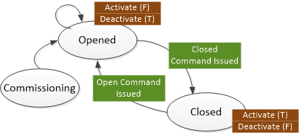

Figure 10. Relay IED States.

### State Diagram

Figure 10 is the state diagram for the operation of the relay IED.

## Hardware Setup

The following is a description of all the hardware used for the relay controllers.

### RTDS

The relay IED controller in conjunction with the RTDS simulation is based on the following hardware.

### Controller

The main controller is a National Instruments sbRIO 9636 running LabVIEW 2014 SP1.

#### Channel Configuration

|  |  |
| --- | --- |
| Channel | Description |
| AO0 | Load Relay Control Signal |
| AO1 | PV Relay Control Signal |

# Appendix A: Communications between EMS/SCADA

Macintosh HD:Users:33i:Desktop:Communication_definitsion.emf

: EMS to SCADA message

: SCADA to EMS message

: SCADA to EMS message (universal)

| **Message Name** | **Information** |
| --- | --- |
| Activate | * Definition: Starts all devices for grid connected mode * Content: None |
| Activate\_failure | * Definition: Notice of failure Activate command * Content: length of error information (UINT32), error information (STR) |
| Activate\_success | * Definition: Confirmation of success of all devices activating * Content: None |
| Bad\_message | * Definition: Message sent from EMS to SCADA or vice-versa if a message is incorrectly formatted * Content: length of message name (UINT8), message name (STR), length of original message content (UINT32), original message content (STR). |
| Black\_start | * Definition: Starts all devices for islanded mode. The sequence does not include the V/f controller, as this is separately configured. * Content: length of startup sequence (UINT32), startup sequence as a comma-separated list of IED names (STR) |
| Black\_start\_failure | * Definition: Notice of failure to start devices. * Content: length of startup sequence (UINT32), startup sequence as a comma-separated list (STR), length of error information (UINT32), error information (STR) |
| Black\_start\_success | * Definition: Confirmation of success of all devices starting * Content: length of startup sequence (UINT32), startup sequence as a comma-separated list (STR) |
| CID\_file | * Definition: Send SCADA .CID individual file * Content: length of CID file name (UINT8), CID file name (STR), length of file (UINT32), file (STR) |
| CID\_file\_error | * Definition: Notice from SCADA to EMS that there was a problem parsing/using a given .CID file * Content: length of CID file name (UINT8), CID file name (STR), length of error information (UINT32), error information (STR) |
| CID\_file\_received | * Definition: Received confirmation that file has been received. * Content: length of CID file name (UINT8), CID file name (STR) |
| CID\_load | * Definition: Notification from EMS to SCADA to load defined .CID file and to perform initial connection to IED * Content: length of CID file name (UINT8), CID file name (STR), length of IED name (UINT8), IED name (STR) |
| CID\_load\_failure | * Definition: Notification from SCADA to EMS that the .CID file was not loaded successfully * Content: length of CID file name (UINT8), CID file name (STR), length of IED name (UINT8), IED name (STR), length of error information (UINT32), error information (STR) |
| CID\_load\_success | * Definition: Notification of successfully loading .CID file and performing initial connection to IED sent from SCADA to EMS * Content: length of CID file name (UINT8), CID file name (STR), length of IED name (UINT8), IED name (STR) |
| CID\_unload | * Definition: Notification from EMS to SCADA to unload defined IED and close communication * Content: length of IED name (UINT8), IED name (STR) |
| CID\_unload\_failure | * Definition: Notification from SCADA to EMS that the IED was not unloaded successfully * Content: length of IED name (UINT8), IED name (STR), length of error information (UINT32), error information (STR) |
| CID\_unload\_success | * Definition: Notification of successfully unloading IED sent from SCADA to EMS * Content: length of IED name (UINT8), IED name (STR) |
| Device\_activate | * Definition: Activates a device manually, outside of Activate or Black\_start * Content: length of IED name (UINT8), IED name (STR) |
| Device\_activate\_failure | * Definition: Notice of failure of device being able to activate * Content: length of IED name (UINT8), IED name (STR), length of error information (UINT32), error information (STR) |
| Device\_activate\_success | * Definition: Confirmation of device’s activation * Content: length of IED name (UINT8), IED name (STR) |
| Device\_deactivate | * Definition: Manually deactivates a device, outside of shedding or Shutdown * Content: length of IED name (UINT8), IED name (STR) |
| Device\_deactivate\_failure | * Definition: Notice of a device failing to deactivate * Content: length of IED name (UINT8), IED name (STR), length of error information (UINT32), error information (STR) |
| Device\_deactivate\_success | * Definition: Notice of successful deactivation. * Content: length of IED name (UINT8), IED name (STR) |
| Device\_parameter\_get | * Definition: This message is sent from EMS to SCADA to request IED device parameters * Content: length of IED name (UINT8), IED name (STR), length of parameter name (UINT8), parameter name (STR) |
| Device\_parameter\_get\_failure | * Definition: This message is sent from SCADA to EMS on a failure to get a device parameter * Content: length of IED name (UINT8), IED name (STR), length of parameter name (UINT8), parameter name (STR), length of error string (UINT32), error string (STR) |
| Device\_parameter\_get\_success | * Definition: This message is sent from SCADA to EMS to provide the requested device parameter * Content: length of IED name (UINT8), IED name (STR), length of parameter name (UINT8), parameter name (STR), parameter data type (ENUM), parameter (varies) |
| Device\_parameter\_set | * Definition: This message is sent from EMS to SCADA to set IED device parameters * Content: length of IED name (UINT8), IED name (STR), length of parameter name (UINT8), parameter name (STR), parameter data type (ENUM), parameter (varies) |
| Device\_parameter\_set\_failure | * Definition: Notification of failure to apply device parameter sent from SCADA to EMS * Content: length of IED name (UINT8), IED name (STR), length of parameter name (UINT8), parameter name (STR), length of error string (UINT32), error string (STR) |
| Device\_parameter\_set\_success | * Definition: Confirmation of success of application of device parameter sent from SCADA to EMS * Content: length of IED name (UINT8), IED name (STR), length of parameter name (UINT8), parameter name (STR) |
| Island | * Definition: Moves microgrid from grid-connected to islanded mode * Content: None |
| Island\_failure | * Definition: Notice of failure to island microgrid * Content: length of error information (UINT32), error information (STR) |
| Island\_success | * Definition: Confirmation of success of transition to islanded mode * Content: None |
| Island\_control\_set | * Definition: Defines the device that will change from P/Q to V/f mode when islanding occurs. * Content: length of IED name (UINT8), IED name (STR) |
| Island\_control\_set\_failure | * Definition: Notice of failure of the device being able to transition to V/f mode * Content: length of IED name (UINT8), IED name (STR), length of error information (UINT32), error information (STR) |
| Island\_control\_set\_success | * Definition: Confirmation of success of the devices’ capability to take on this role * Content: length of IED name (UINT8), IED name (STR) |
| Measurement\_get | * Definition: This message is sent by the EMS to the SCADA to request a single measurement. * Content: length of IED name (UINT8), IED name (STR), length of measurement name (UINT8), measurement name (STR) |
| Measurement\_get\_failure | * Definition: Notice of failure from the SCADA to the EMS regarding getting the requested measurement point * Content: length of IED name (UINT8), IED name (STR), length of measurement name (UINT8), measurement name (STR), length of error information (UINT32), error information (STR) |
| Measurement\_get\_success | * Definition: This message from SCADA is the successful return of the measurement data requested by the EMS. * Content: length of IED name (UINT8), IED name (STR), length of measurement name (UINT8), measurement name (STR), measurement (DBL). |
| Measurement\_get\_multiple | * Definition: This message is sent by the EMS to the SCADA to request multiple measurements. * Content: length of IED names (UINT32), IED names (STR), length of measurement names (UINT32), measurement names (STR) |
| Measurement\_get\_multiple\_failure | * Definition: Notice of failure from the SCADA to the EMS regarding getting the requested measurement point * Content: length of IED names (UINT32), IED names (STR), length of measurement names (UINT32), measurement names (STR), length of error information (UINT32), error information (STR) |
| Measurement\_get\_multiple\_success | * Definition: This message from SCADA is the successful return of the measurement data requested by the EMS. * Content: length of IED names (UINT32), IED names (STR), length of measurement names (UINT32), measurement names (STR), measurement array ([DBL]) |
| PCC\_relay\_set | * Definition: Defines the device that provides the point of common coupling * Content: length of IED name (UINT8), IED name (STR) |
| PCC\_relay\_set\_failure | * Definition: Notice of failure of device being able to open a relay * Content: length of IED name (UINT8), IED name (STR), length of error information (UINT32), error information (STR) |
| PCC\_relay\_set\_success | * Definition: Confirmation of success of the devices’ capability to take on this role * Content: length of IED name (UINT8), IED name (STR) |
| Setpoint\_set | * Definition: Setpoint sent from EMS to SCADA for dispatch of resources * Content: length of IED name (UINT8), IED name (STR), length of variable name (UINT8), variable name (STR), setpoint (DBL) |
| Setpoint\_set\_failure | * Definition: Notice of failure of application of set points sent from IED to SCADA to EMS or from SCADA to EMS * Content: length of IED name (UINT8), IED name (STR), length of variable name (UINT8), variable name (STR), length of error information (UINT32), error information (STR). |
| Setpoint\_set\_success | * Definition: Confirmation of success of application of set points sent from IED to SCADA to EMS * Content: length of IED name (UINT8), IED name (STR), length of variable name (UINT8), variable name (STR) |
| Setpoint\_multiple\_set | * Definition: Setpoints sent from EMS to SCADA for dispatch of resources * Content: length of IED names (UINT32), IED names (STR), length of variable names (UINT32), variable names (STR), setpoints ([DBL]) |
| Setpoint\_multiple\_set\_failure | * Definition: Notice of failure of application of set points sent from IED to SCADA to EMS or from SCADA to EMS * Content: length of IED names (UINT32), IED names (STR), length of variable names (UINT32), variable names (STR), length of error information (UINT32), error information (STR) |
| Setpoint\_multiple\_set\_success | * Definition: Confirmation of success of application of set points sent from IED to SCADA to EMS * Content: length of IED names (UINT32), IED names (STR), length of variable names (UINT32), variable names (STR) |
| Shed\_set | * Definition: Defines loads to shed during islanding * Content: length of sequence (UINT32), shed sequence as a comma-separated list of IED names (STR), Load Ratings ([DBL]) |
| Shed\_set\_failure | * Definition: Notice of failure to set shed sequence * Content: length of sequence (UINT32), shed sequence as a comma-separated list of IED names (STR), length of error information (UINT32), error information (STR) |
| Shed\_set\_success | * Definition: Confirmation of success of setting shed sequence * Content: length of sequence (UINT32), shed sequence as a comma-separated list of IED names (STR) |
| Shutdown | * Definition: Performs shutdown sequence for all devices within the microgrid * Content: None |
| Shutdown\_failure | * Definition: Notice of failure to shutdown microgrid * Content: length of error information (UINT32), error information (STR) |
| Shutdown\_success | * Definition: Confirmation of success of shutdown * Content: None |
| Synchronize | * Definition: Moves microgrid from islanded to grid-connected mode * Content: None |
| Synchronize\_failure | * Definition: Notice of failure to connect microgrid to the larger grid * Content: length of error information (UINT32), error information (STR). |
| Synchronize\_success | * Definition: Confirmation of success of transition to grid-connected mode * Content: None |
| Unknown\_message | * Definition: Message sent from EMS to SCADA or vice versa if an undefined message was sent * Content: length of message name (UINT8), message name (STR) |

The Data Type Enumerated List Is as Follows:

|  |  |  |
| --- | --- | --- |
| Number | Data Type | Number of Bytes |
| 0 | Boolean (BOOL) | 1 |
| 1 | Unsigned 16-bit integer (UINT16) | 2 |
| 2 | Unsigned 32-bit integer (UINT32) | 4 |
| 3 | Signed 32-bit integer (INT32) | 4 |
| 4 | Double-precision floating point (DBL) | 8 |
| 5 | String (Size is prepended with a UINT8) (STR) | Varies |

The Enum itself is a UINT8.

# Appendix B: EMS States

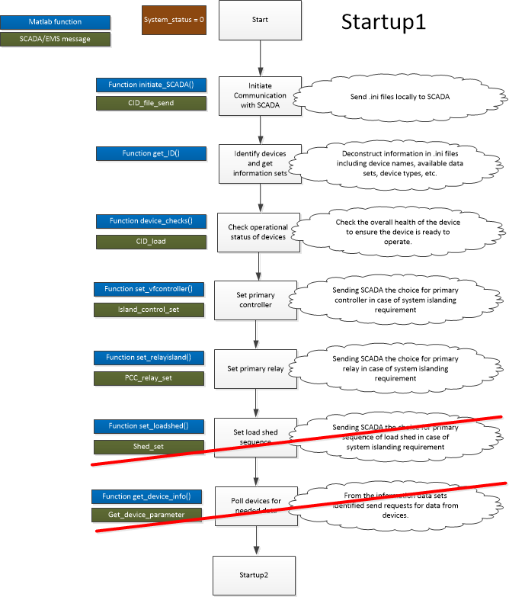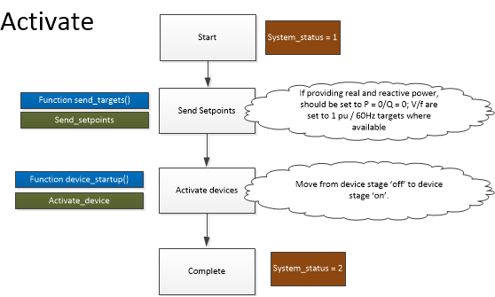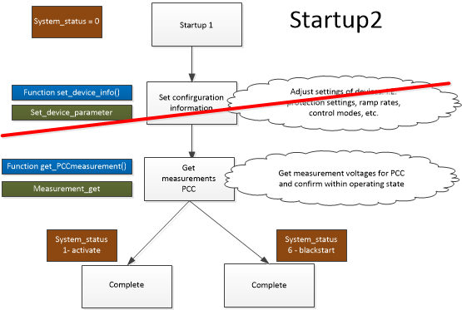

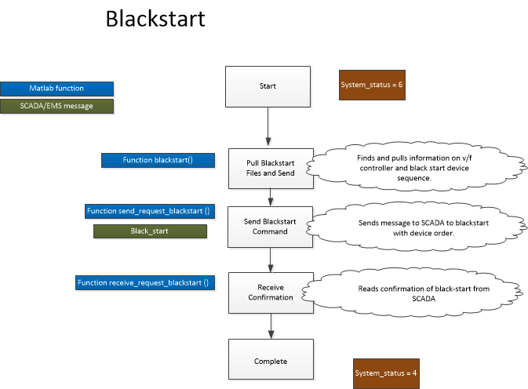

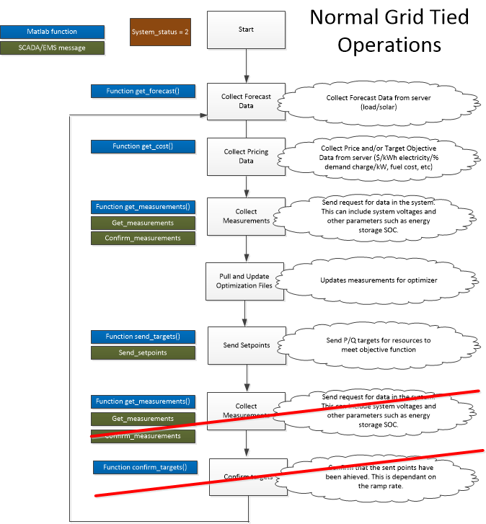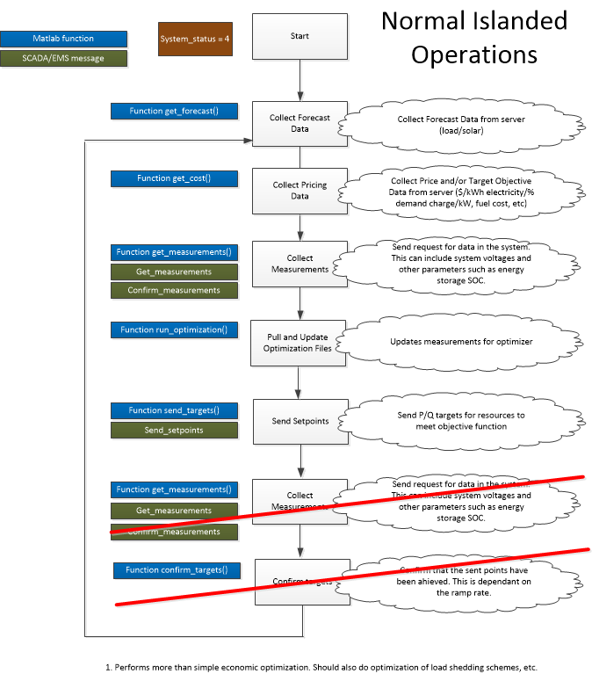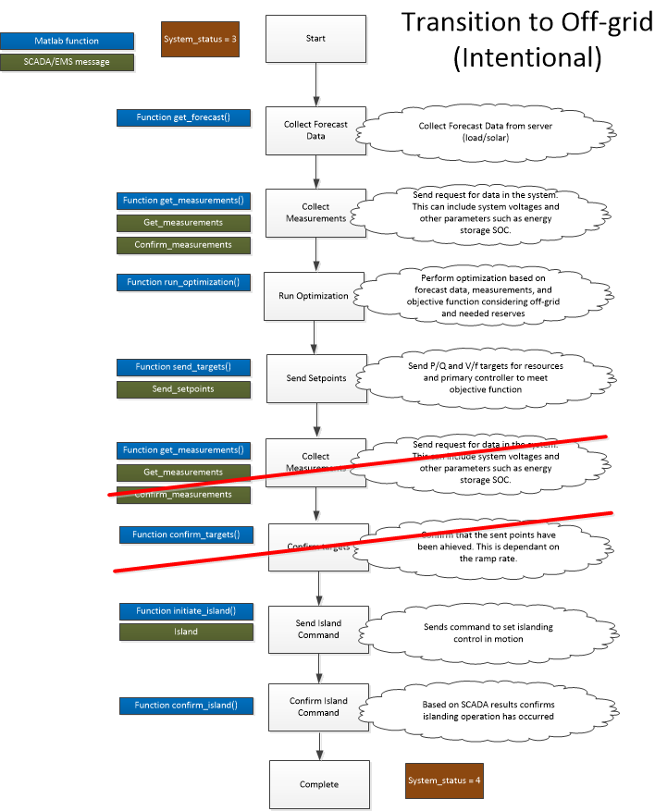

C:\Users\33i\AppData\Local\Microsoft\Windows\INetCache\Content.Word\CSEISMIC_designs_vs2.emf

# Appendix C: Modbus Files

ES1.ini

[DeviceInfo]

Name = "ES1"

DeviceType = "Storage"

IPAddress = "192.168.48.151"

Port = 502

[Activations]

ActivateControl = 00010

ActivateTimeout = 30010

ActivateStatus = 10010

DeactivateControl = 00020

DeactivateTimeout = 30020

DeactivateStatus = 10011

Watchdog = 40010

[Parameters]

BatteryCapacity = 34083

RampRate = 39403

GenerationModeSelect = 10030

DroopSelect = 10031

TransitionToSync = 10032

[Setpoints]

Real = 40030

Reactive = 40040

Voltage = 40050

Frequency = 40060

[Measurements]

CurrentPhaseA = 30030

CurrentPhaseB = 30040

CurrentPhaseC = 30050

VoltagePhaseA = 30130

VoltagePhaseB = 30140

VoltagePhaseC = 30150

RealPowerPhaseA = 30230

RealPowerPhaseB = 30240

RealPowerPhaseC = 30250

ReactivePowerPhaseA = 30330

ReactivePowerPhaseB = 30340

ReactivePowerPhaseC = 30350

StateofCharge = 30500

[Scaling]

Mainswitch (PCC)

[DeviceInfo]

Name = "Mainswitch"

DeviceType = "MainSwitch"

IPAddress = "192.168.48.250"

Port = 502

[Activations]

ActivateControl = 00010

ActivateTimeout = 30010

ActivateStatus = 10010

DeactivateControl = 00020

DeactivateTimeout = 30020

DeactivateStatus = 10011

Watchdog = 40010

[Parameters]

HighVoltageLimit = 43026

LowVoltageLimit = 43026

ForwardCurrentLimit = 43026

ReverseCurrentLimit = 43026

[Setpoints]

[Measurements]

CurrentPhaseA = 30030

CurrentPhaseB = 30040

CurrentPhaseC = 30050

VoltagePhaseA = 30130

VoltagePhaseB = 30140

VoltagePhaseC = 30150

RealPowerPhaseA = 30230

RealPowerPhaseB = 30240

RealPowerPhaseC = 30250

ReactivePowerPhaseA = 30330

ReactivePowerPhaseB = 30340

ReactivePowerPhaseC = 30350

[Scaling]

Relay 1

[[DeviceInfo]

Name = "R1"

DeviceType = "Relay"

IPAddress = "192.168.48.71"

Port = 502

[Activations]

ActivateControl = 00010

ActivateTimeout = 30010

ActivateStatus = 10010

DeactivateControl = 00020

DeactivateTimeout = 30020

DeactivateStatus = 10011

Watchdog = 40010

[Parameters]

HighVoltageLimit = 43026

LowVoltageLimit = 43026

ForwardCurrentLimit = 43026

ReverseCurrentLimit = 43026

[Setpoints]

[Measurements]

CurrentPhaseA = 30030

CurrentPhaseB = 30040

CurrentPhaseC = 30050

VoltagePhaseA = 30130

VoltagePhaseB = 30140

VoltagePhaseC = 30150

RealPowerPhaseA = 30230

RealPowerPhaseB = 30240

RealPowerPhaseC = 30250

ReactivePowerPhaseA = 30330

ReactivePowerPhaseB = 30340

ReactivePowerPhaseC = 30350

[Scaling]

1. Current flow from the device is used as the reference for a device’s state. [↑](#footnote-ref-1)